Lab 3 (Lecture 4-5)

Make the following Racing Car Scene in Unity

Add following components:

1. Download provided Assets of Car racing game from google classroom in Unity Assets folder of your system
2. Make a new 3D project as FA22-BCS-000_CarRacingGame
3. AddTwo plains as road and roadside
4. Add road texture to road and grass texture to roadside (increase texture tiling)
5. Add buildings on road sides by applying textures on cube of different size
6. Add Skybox to the scene
7. Add Player Racing car (provided at google classroom) from PREFAB folder of MyCar to the scene with a box collider
8. Fix the car texture by selecting all materials from MayCar🡪Materials🡪-Common and FoCE folder 🡪GOTO Edit🡪Rendering🡪Material🡪Convert Material to URP
9. Add Traffic with box colliders
10. Add CarMovement script at the car which turn the car left (left arrow key), right (right arrow key) and move it forward (up arrow key)
11. Add CameraScript on Camera which makes the camera follow the car and TrafficScript on each traffic car that moves it without any user input in forward direction only
12. Player car and traffic should move forward in **game loop**
13. Add audio source to the car and collision detection method in the CarMovement such that if player car collides with traffic or building, it should collapse and game should end
14. Add Fuel Text with maximum value 100, which should decrease as the car moves forward
15. Add fuel drums which will refeul the car when it collides with fuel drum
16. If Player continues to move forward without any collision till 3 minutes, display “You Win”,Text from where u can replay or exit the game.

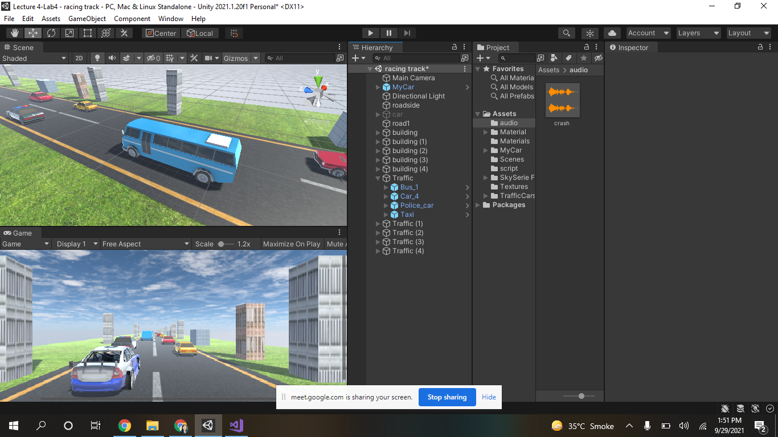

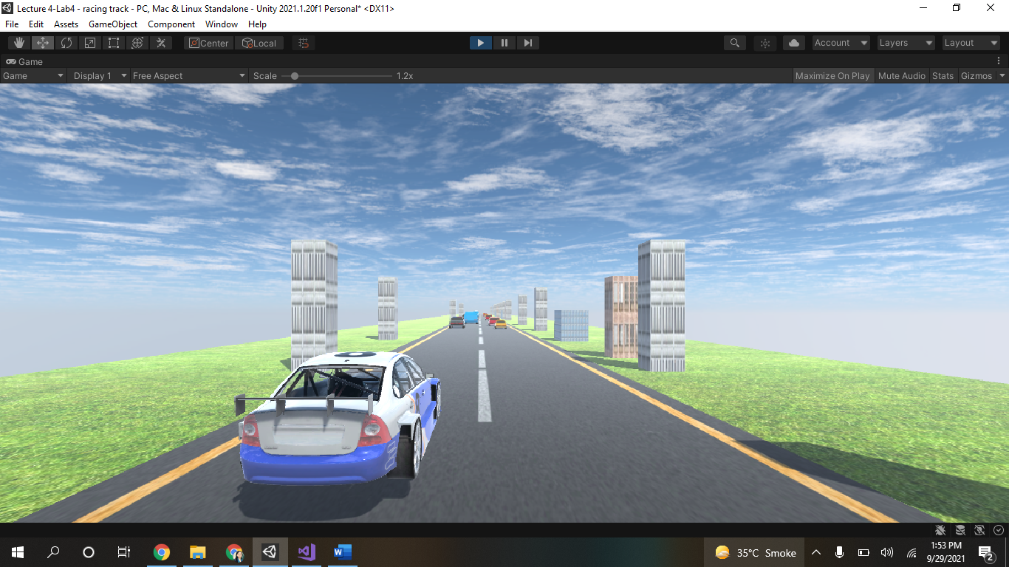

Timer script:

using UnityEngine;

using UnityEngine.UI;

public class SimpleTimer : MonoBehaviour

{

public float timeRemaining = 180f; // Countdown time in seconds

public Text timerText; // UI Text component

void Update()

{

if (timeRemaining > 0)

{

timeRemaining -= Time.deltaTime;

timerText.text = timeRemaining.ToString("F1"); // Display with 1 decimal place

}

else

{

timerText.text = "Time's Up!";

enabled = false;

}

}

}